WEATHER CLIMATE WATER | 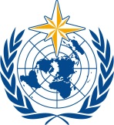  World Meteorological Organization  COMMISSION FOR WEATHER, CLIMATE, WATER AND RELATED ENVIRONMENTAL SERVICES AND APPLICATIONS  Second Session  17 to 21 October 2022, Geneva | SERCOM-2/Doc. 5.10(3)
Submitted by:
Chair
20.X.2022
APPROVED
AGENDA ITEM 5: TECHNICAL REGULATIONS AND OTHER TECHNICAL MATTERS
AGENDA ITEM 5.10: Integrated health services

IMPLEMENTATION PLAN FOR ADVANCING INTEGRATED CLIMATE AND HEALTH SCIENCE AND SERVICES 2023–2033

DRAFT RECOMMENDATION

Draft Recommendation 5.10(3)/1 (SERCOM-2)
Implementation Plan for Advancing Integrated Climate and Health Science and Services 2023–2033
THE COMMISSION FOR WEATHER, CLIMATE, WATER AND RELATED ENVIRONMENTAL SERVICES AND APPLICATIONS,
Recalling Resolution 8 (EC-73) – Integrated health services,
Having examined:
(1) SERCOM-2/Doc. 5.10(3) and SERCOM-2/INF. 5.10(3a) – Implementation Plan for Advancing Integrated Climate and Health Science and Services 2023–2033,
(2) SERCOM-2/INF. 5.10(3b) – Conceptual Framework for Integrated Climate and Health Science and Services, highlighting good practices and principles necessary for implementation success, and
(3) SERCOM-2/INF. 5.10(3c) – Interim progress on the Health, Environment, and Climate Science to Services Master Plan 2019–2022,
Recommends to the Executive Council to approve the Implementation Plan for Advancing Integrated Climate and Health Science and Services 2023–2033, through the draft resolution provided in the annex to the present recommendation.

_____________

______
Annex: 1

Annex to draft Recommendation 5.10/3 (SERCOM-2)
Draft Resolution ##/1 (EC-76)
THE EXECUTIVE COUNCIL,
Recalling:
(1) Resolution 33 (Cg-18) – Advancing Integrated Health Services,
(2) Resolution 1 (Cg-Ext 2012) – Implementation Plan of the Global Framework for Climate Services, whereby health was deemed a priority sector,

(3) Resolution 47 (Cg-17) – Global Atmosphere Watch Programme, and Decision 62 (EC-68) – Global Atmosphere Watch Implementation Plan for the period 2016–2023,
(4) The Health, Environment, and Climate Science to Services Master Plan (2019–2023) World Meteorological Congress: Abridged Final Report of the Eighteenth session (WMO-No. 1236), Part II,
(5) Annex to Resolution 1 (SERCOM-1) - Terms of Reference of Standing Committees and Study Groups,
(6) Recommendation 7 (SERCOM-1) – Integrated Health Services,
Noting:
(1) The Working arrangements with the World Health Organization (WHO) (1952),
(2) The 2018 WHO-WMO Collaboration Framework on Climate, Environment and Health,
(3) The Joint WHO-WMO Office for Climate and Health, established in 2014, is a critical coordination mechanism between WHO and WHO to ensure closer interagency collaboration and alignment, and support implementation of the proposed mechanisms and actions,
(4) That funding for many joint activities will be provided through extrabudgetary sources,
(5) The ongoing collaboration between climate and health actors at regional and national levels,
(6) The WMO Integrated Health Focal Points as regional and national representatives are key partners to support implementation of proposed mechanisms and actions.
Mindful that the sixth IPCC Assessment Report states with very high confidence that climate hazards are increasingly contributing to a growing number of adverse health outcomes, including communicable and non-communicable diseases, in multiple geographical areas,
Recognizing that climate, weather, air pollution, UV radiation, extreme events and other environmental factors impact human health in interconnected, cascading and compounding ways calling for integrated approaches at global, regional, and national level,
Having considered Recommendation 5.10/3 (SERCOM-2),
Having agreed Recommendation 5.10/3 (SERCOM-2),
Decides to endorse the Implementation Plan for Advancing Integrated Climate and Health Science and Services 2023–2033;
Requests:
(1) The Services Commission to identify and designate the appropriate body for coordination and technical support of the work on Integrated Health Services (2023–2033) at SERCOM-3 (2024);
(2) The Secretary-General to provide the necessary to support to maintain and/or establish the mechanisms outlined as necessary for implementation;
Invites:
(1) Members to support implementation of the proposed actions and mechanisms; facilitate collaboration of their NMHSs and other relevant actors with the health community to enhance integrated climate, environment and health science and services; and to nominate health experts to the WMO Expert Network;
(2) The World Health Organization, Members, and development partners to consider funding such arrangements;
(3) The World Health Organization to nominate experts to the WMO Expert Network to support proposed mechanisms and structures established by the Services Commission.
__________
See Annex (Overview of the Implementation Plan)
SERCOM-2/INF. 5.10 (3a) - Implementation Plan for Advancing Integrated Climate and Health Science and Services 2023–2033) for more information.
SERCOM-2/INF. 5.10 (3b) - Conceptual Framework for Integrated Climate and Health Science and Services, highlighting good practices and principles necessary for implementation success
SERCOM-2/INF. 5.10 (3c) - Interim progress on the Health, Environment, and Climate Science to Services Master Plan 2019–2022
Annex to draft Resolution ##/1 (EC-76)
Overview of the Implementation Plan for Advancing Integrated Climate, Environment and Health Science and Services 2023–2033
1. The Implementation Plan for Advancing Climate, Environment and Health Science and Services (SERCOM-2/INF. 5.10(1)) outlines innovative approaches, sustained mechanisms, and engagement opportunities for delivering demand driven climate science and services for health protection. This Plan operationalizes the objectives of the WHO-WMO Collaboration Framework on Climate, Environment and Health (2018), the Cg-18 Resolution 33 on Advancing Integrated Health Services, and the WHO-WMO Health, Environment and Climate Science to Services Master Plan (2019–2023).
2. The joint leadership and implementation of the proposed mechanisms and actions by both the WMO and the World Health Organization are critical to achieving “better health and wellbeing for people facing existing and emerging extreme weather events, climate change, and environmental risks through the effective integration of climate, environment, and health science and services across the world”.
3. A new Conceptual Framework and set of good practices accompanies this plan in SERCOM-2/INF. 5.10 (2) to drive transformational change in the co-development and use of demand driven and reliable integrated climate, environment and health science and services. The plan is organized according to three dimensions and uses a nexus approach to allow flexibility and tailoring of this plan as relevant to local to regional contexts.
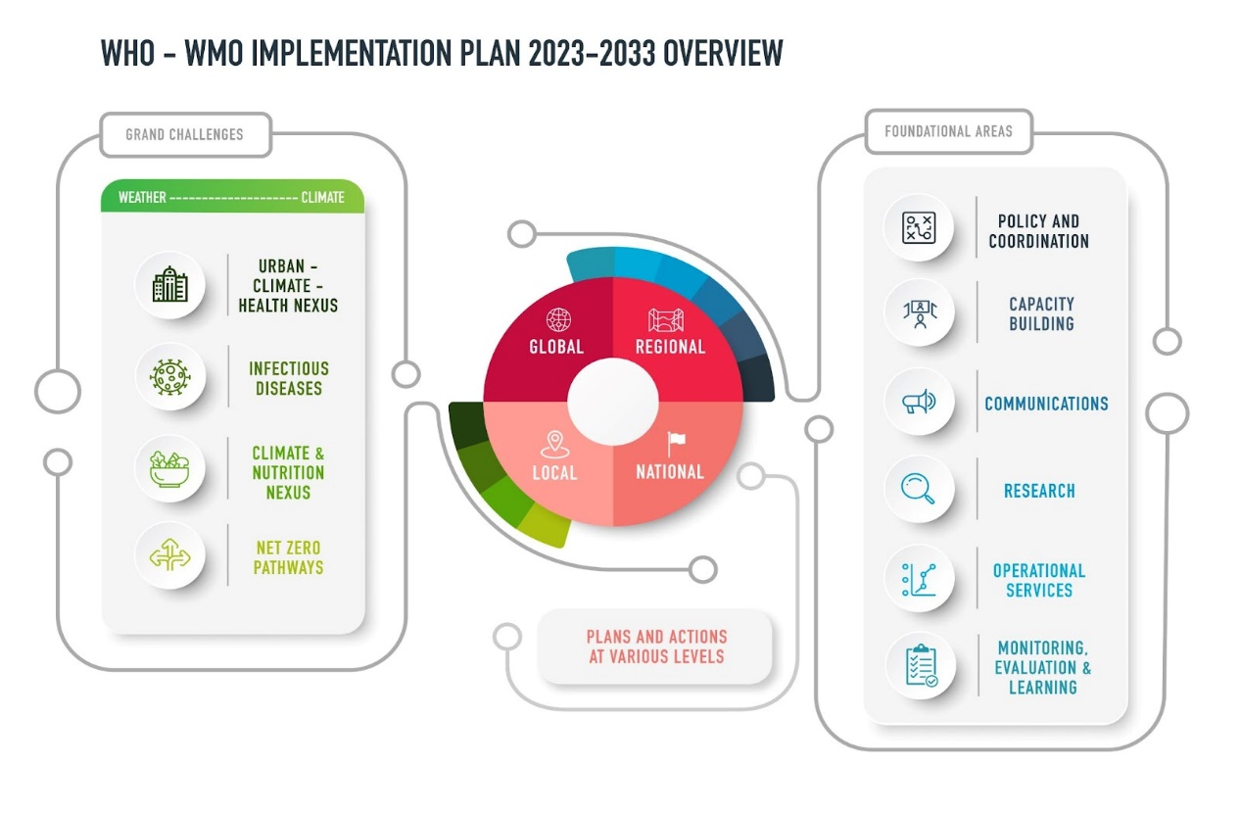
Figure 1. Dimensions of the Implementation Plan include: Four grand challenge thematic areas with activities that address needs from extreme weather to climate timescales (Left); Six foundational support areas (Right), and Plans and Actions which will occur at diverse spatial scales according to needs and priorities (Centre).
4. Four grand challenge areas promote catalytic actions to enhance science and services applications in focus areas of public health importance:
(1) Urban-Climate-Health-Nexus: e.g. will address health risks related to extreme heat, urban heat islands, wildfire, air and water [Botswana] quality, and other urban health risks amplified by climate change and its increasing variability [Russian Federation];
(2) Infectious Diseases: e.g. will help predict, monitor, and manage climate sensitive infectious diseases risks;
(3) Climate and Nutrition Nexus: e.g. to understand, develop policies, and actions to protect health and nutrition from food system instability and changes due to climate change;
(4) Climate Resilient and Low Carbon Health Systems: e.g. to support climate resilience of health systems and the health sector NetZero energy transition.
5. Foundational support areas propose actions and mechanisms to lead transformational change in climate and health science, services, and policy. These include activities and mechanisms to enhance: Policy and Coordination; Capacity building; Communications; Research; Operational Services; and Monitoring, Evaluation, and Learning.
6. This Implementation Plan envisions both top-down and bottom-up actions which take different approaches at local, national, regional, and global level. The nexus areas cover many but not all health issues affected by climate and environmental changes. Other climate, environment, and health related priorities may be addressed through specific place-based plans at national or regional levels. Similarly, actions related to the foundational support areas may also vary from region to region according to needs. It is intended that new and existing mechanisms will be networked to optimize resources and enhance capacity and action at all levels.
7. Example actions and mechanisms proposed in the plan include:
- NMHS Focal points form a health community of practice
- Climate and Health Literacy and Skills programme
- Technical Support Teams/Centres of Excellence in Climate and Health
- Expert Teams to address specific requirements and topics
- National and Regional Climate and Health Plans and Coordination mechanisms
- Climate and Health Fellowship and Secondment programme
- Climate and Health science communication toolkit and online resources
- WHO-WMO Joint Programme for Climate, Health, and Environment
8. Three implementation phases of three years each will follow an inception year in 2023.
9. Monitoring, evaluation, and learning activities will inform an iterative review process, and further activities and adjustments are expected to be responsive to national and regional needs and progress.
10. Key to the success of the implementation plan will be leveraging existing and new institutional partnerships, as well as joined up extrabudgetary resource mobilization.
__________________

